**Online Food Ordering Management System**

***Submitted by***

***Aditya Gupta (RA2211026010434)***

***Abhishek Chaurasia (RA2211026010431)***

***Under the Guidance of***

**Dr. V. V. RAMALINGAM**

**Associate Professor**

**Department of Computing Technologies**

***In partial satisfaction of the requirements for the degree of***

## **BACHELOR OF TECHNOLOGY**

**in**

**COMPUTER SCIENCE ENGINEERING**

**SCHOOL OF COMPUTING**

# **COLLEGE OF ENGINEERING AND TECHNOLOGY**

**SRM INSTITUTE OF SCIENCE AND TECHNOLOGY**

**KATTANKULATHUR - 603203**

**MAY 2023**

SRM INSTITUTION OF SCIENCE AND TECHNOLOGY

KATTANKULATHUR-603203

**BONAFIDE CERTIFICATE**

Certified that this Project Report titled **“Online Food Ordering Management System””** is the bonafide work done by **Aditya Gupta [RA2211026010434]** and **Abhishek Chaurasia [RA2211026010431]** who completed the project under my supervision. Certified further, that to the best of my knowledge the work reported herein does not form part of any other work.

| **SIGNATURE**  **Dr.V.V.Ramalingam**  **OODP – Course Faculty**  Associate Professor  Department of Computing Technologies  SRMIST | **SIGNATURE**  **Dr.M.Pushpalatha**  Professor & Head  Department of Computing Technologies  School of Computing  SRMIST |
| --- | --- |

**TABLE OF CONTENTS**

|  |  |  |
| --- | --- | --- |
| **S.No** | **CONTENTS** | **PAGE NO** |
| 1. | Problem Statement | **4** |
| 2. | Modules of Project | **5** |
| 3. | Diagrams | **6** |
|  | 1. Use case Diagram | **6** |
|  | 1. Class Diagram | **7** |
|  | 1. Sequence Diagram | **8** |
|  | 1. Collaboration Diagram | **9** |
|  | 1. State Chart Diagram | **10** |
|  | 1. Activity Diagram | **11** |
|  | 1. Package Diagram | **12** |
|  | 1. Component Diagram | **13** |
|  | 1. Deployment Diagram | **14** |
| 4. | Code and Output Screenshots | **15** |
| 5. | Conclusion and Results | **25** |
| 6. | References | **26** |

# ABSTRACT

Online Food Ordering management System is web application to online food management system. This system is to provide service facility to restaurant and also to the customer. The services that are provided is food ordering and table reservation by the customer through the system online, customer information management, menu information management and report. Main objective of the system is to provide ordering serve by online to customer. This project will develop restaurant management and enhances business.

# MODULE DESCRIPTION

With the system online, ordering and reservation, management will become easier and systematic to replace traditional system where papers are still being used. Furthermore, this system is applicable any time. During the development of online restaurant ordering management system, the methodology being used is phases in prototyping model. Each process during the development process is followed by each phases in prototyping model. This project is to facilitate customer in making online ordering and reservations.

# Use case diagram with explanation

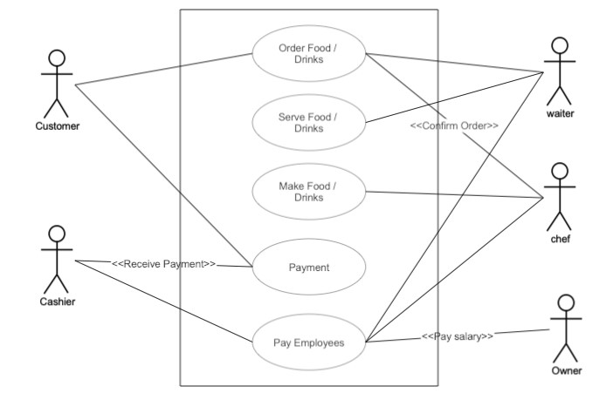

**Explanation:**

A use case diagram is used to represent the dynamic behaviour of a system. It encapsulates the system's functionality by incorporating use cases, actors, and their relationships. It models the tasks, services, and functions required by a system/subsystem of an application. It depicts the high-level functionality of a system and also tells how the user handles a system.

# Class diagram with explanation

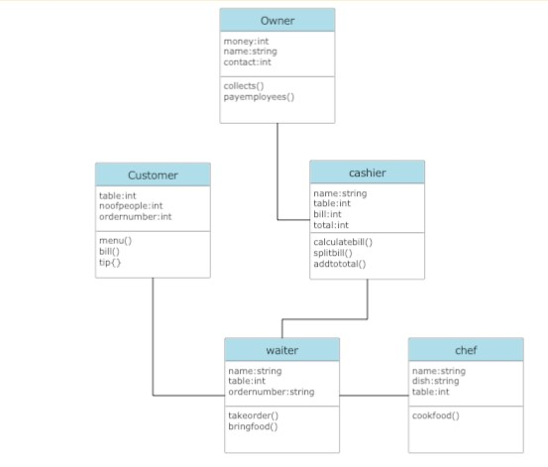

**Explanation:**

Class diagram describes the attributes and operations of a class and also the constraints imposed on the system. The class diagrams are widely used in the modeling of object oriented systems because they are the only UML diagrams, which can be mapped directly with object-oriented languages.

# Sequence diagram with explanation

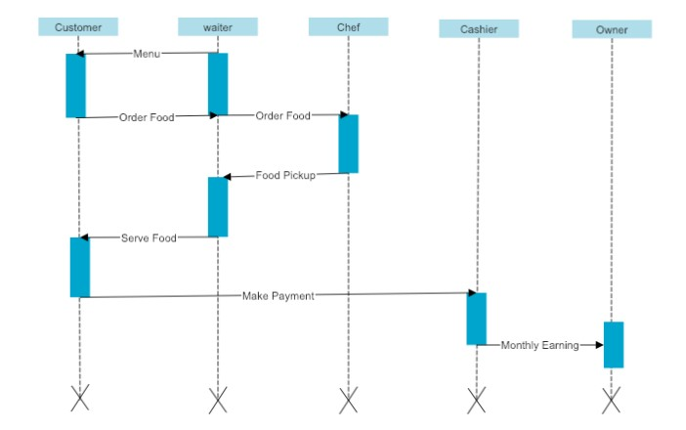

**Explanation:**

UML Sequence Diagrams are interaction diagrams that detail how operations are carried out.

They capture the interaction between objects in the context of a collaboration. Sequence Diagrams are time focus and they show the order of the interaction visually by using the vertical axis of the diagram to represent time what messages are sent and when. The sequence diagram is used primarily to show the interactions between objects in the sequential order that those interactions occur.

# Communication diagram with explanation

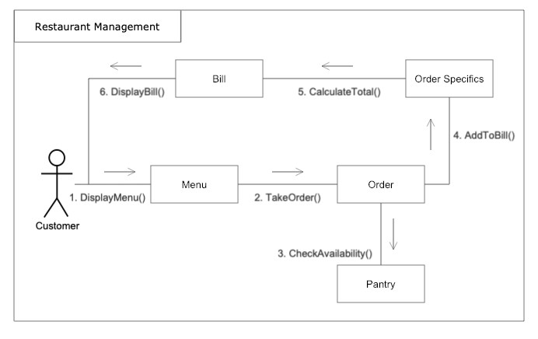

**Explanation:**

A communication diagram is an extension of object diagram that shows the objects along with the messages that travel from one to another. In addition to the associations among objects, communication diagram shows the messages the objects send each other.

Communication diagrams, formerly known as collaboration diagrams, are almost identical to sequence diagrams in UML, but they focus more on the relationships of objects—how they associate and connect through messages in a sequence rather than interactions.

# State chart diagram with explanation

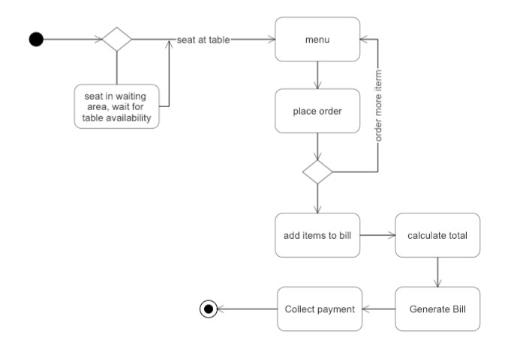

**Explanation:**

State transition diagrams provide a way to model the various states in which an object can exist. While the class diagram shows a static picture of the classes and their relationships, state transition diagrams model the dynamic behavior of a system in response to external events (stimuli

Statechart diagram describes the flow of control from one state to another state. States are defined as a condition in which an object exists and it changes when some event is triggered. The most important purpose of Statechart diagram is to model lifetime of an object from creation to termination.

# Activity diagram with explanation

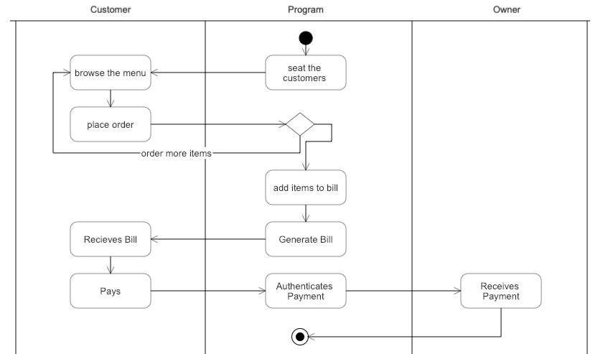

**Explanation:**

Activity diagrams describe the activities of a class. They are similar to state transition diagrams and use similar conventions, but activity diagrams describe the behavior/states of a class in response to internal processing rather than external events.

Activity diagram is basically a flowchart to represent the flow from one activity to another activity. The activity can be described as an operation of the system. The control flow is drawn from one operation to another. This flow can be sequential, branched, or concurrent.

# Package diagram with explanation

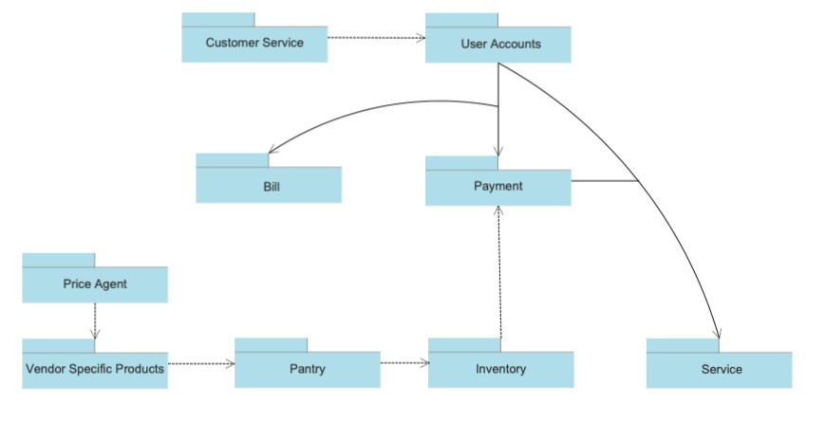

**Explanation:**

Package diagrams are structural diagrams used to show the organization and arrangement of various model elements in the form of packages. A package is a grouping of related UML elements, such as diagrams, documents, classes, or even other packages.

Each element is nested within the package, which is depicted as a file folder within the diagram, then arranged hierarchically within the diagram. Package diagrams are most commonly used to provide a visual organization of the layered architecture within any UML classifier, such as a software system.

# Component diagram with explanation

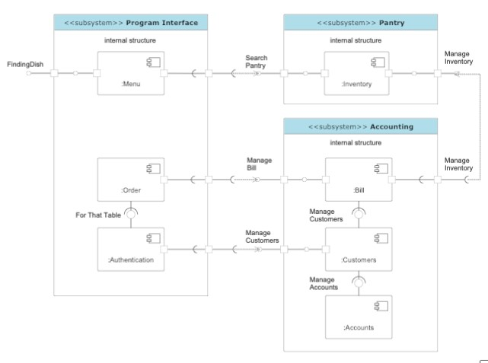

**Explanation:**

A component diagram in the Unified Modelling Language depicts how components are wired together to form larger components and or software systems. Components diagrams can be used to illustrate the structure of arbitrarily complex systems.

A component diagram is used to break down a large object-oriented system into the smaller components, so as to make them more manageable. It models the physical view of a system such as executables, files, libraries, etc. that resides within the node.

# Deployment diagram with explanation

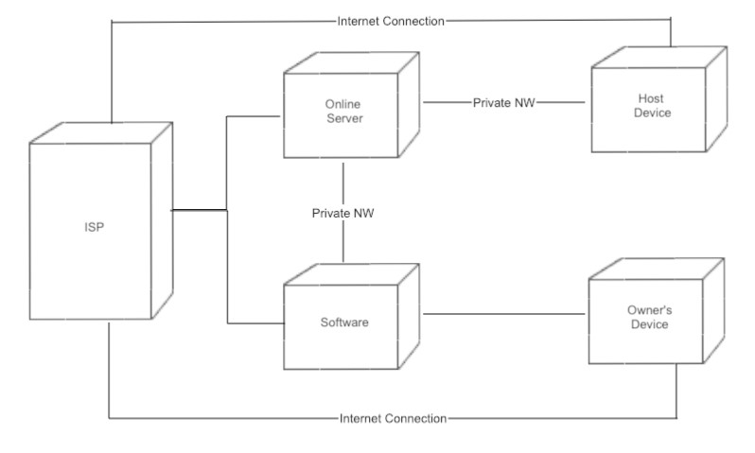

**Explanation:**

A deployment diagram in the Unified Modelling Language serves to model the physical deployment of artifacts on deployment targets. Deployment diagrams show the allocation of Artifacts to Nodes according to the Deployments defined between them. Deployment of an artifact to a node is indicated by placing the artifact inside the node.

A deployment diagram is a UML diagram type that shows the execution architecture of a system, including nodes such as hardware or software execution environments, and the middleware connecting them.

# CODE:

#include<iostream>

#include<conio.h>

using namespace std;

int main()

{

    char name[30], pizza1[]="Chicken Fazita" ,pizza2[]="Chicken Bar BQ" ,pizza3[]="Peri Peri" ,pizza4[]="Creamy Max", roll1[]="Chicken Chatni Roll", roll2[]="Chicken Mayo Roll", roll3[]="Veg Roll With Fries",bur1[]="Zinger Burger",bur2[]="Chicken Burger",bur3[]="Beef Burger";

    char sand1[]="Club Sandwich", sand2[]="Chicken Crispy Sandwich", sand3[]="Extream Veg Sandwich";

    char bir1[]="Chicken Biryani", bir2[]="Prawn Biryani", bir3[]="Beef Biryani",gotostart ;

    int choice=0,pchoice,pchoice1, quantity;// time=40;

    beginning:

    system("CLS");

    cout<<"\t\t\t----------MR. AABB Fast Food-----------\n\n";

    cout<<"Please Enter Your Name: ";

    cin.getline(name, 20);

    cout<<"Hello "<<name<<"\n\nWhat would you like to order?\n\n";

    cout<<"\t\t\t\t--------Menu--------\n\n";

    cout<<"1) Pizzas\n";

    cout<<"2) Burgers\n";

    cout<<"3) Sandwich\n";

    cout<<"4) Rolls\n";

    cout<<"5) Biryani\n\n";

    cout<<"\nPlease Enter your Choice: ";

    cin>>choice;

    if(choice==1)

     {

        cout<<"\n1) "<<pizza1<<"\n";

        cout<<"2) "<<pizza2<<"\n";

        cout<<"3) "<<pizza3<<"\n";

        cout<<"4) "<<pizza4<<"\n";

        cout<<"\nPlease Enter which Flavour would you like to have?:";

        cin>>pchoice;

        if(pchoice>=1 && pchoice<=5)

        {

            cout<<"\n1) Small Rs.250\n"<<"2) Regular Rs.500\n"<<"3) Large Rs.900\n";

            cout<<"\nChoose Size Please:";

            cin>>pchoice1;

            if(pchoice1>=1 && pchoice1<=3)

            cout<<"\nPlease Enter Quantity: ";

            cin>>quantity;

            switch(pchoice1)

            {

            case 1: choice = 250*quantity;

            break;

            case 2: choice = 500*quantity;

            break;

            case 3: choice = 900*quantity;

            break;

                  }

            system("CLS");

            switch (pchoice1)

            {

             case 1:

             cout<<"\t\t\t--------Your Order---------\n";

             cout<<""<<quantity<<" "<<pizza1;

             cout<<"\nYour Total Bill is"<<choice<<"\nYour Order Will be delivered in 40 Minutes";

             cout<<"\n\nThank you For Ordering From MR.AABB Fast Food\n";

             break;

             case 2:

             cout<<"\t\t--------Your Order---------\n";

             cout<<""<<quantity<<"  "<<pizza2;

             cout<<"\nYour Total Bill is "<<choice<<"\nYour Order Will be delivered in 40 Minutes";

             cout<<"\nThank you For Ordering From MR.AABB Fast Food\n";

             break;

             case 3:

             cout<<"\t\t--------Your Order---------\n";

             cout<<""<<quantity<<" "<<pizza3;

             cout<<"\nYour Total Bill is"<<choice<<"\nYour Order Will be delivered in 40 Minutes";

             cout<<"\nThank you For Ordering From MR.AABB Fast Food\n";

             break;

             case 4:

             cout<<"\t\t--------Your Order---------\n";

             cout<<""<<quantity<<" "<<pizza4;

             cout<<"\nYour Total Bill is"<<choice<<"\nYour Order Will be delivered in 40 Minutes";

             cout<<"\nThank you For Ordering From MR.AABB Fast Food\n";

             break;

            }

            cout<<"Would you like to order anything else? Y / N:";

            cin>>gotostart;

            if(gotostart=='Y' || gotostart=='y')

            {

              goto beginning;

              //return 0;

            }

        }

     }

     else if(choice==2)

     {

        cout<<"\n1 "<<bur1<<" Rs.180"<<"\n";

        cout<<"2 "<<bur2<<" Rs.150"<<"\n";

        cout<<"3 "<<bur3<<" Rs.160"<<"\n";

        //cout<<"4 "<<pizza4<<"\n";

        cout<<"\nPlease Enter which Burger you would like to have?: ";

        cin>>pchoice1;

        if(pchoice1>=1 && pchoice1<=3)

        {

            cout<<"\nPlease Enter Quantity: ";

            cin>>quantity;

            switch(pchoice1)

            {

            case 1: choice = 180*quantity;

            break;

            case 2: choice = 150*quantity;

            break;

            case 3: choice = 160*quantity;

            break;

            }

            system("CLS");

            switch (pchoice1)

            {

             case 1:

             cout<<"\t\t--------Your Order---------\n";

             cout<<""<<quantity<<" "<<bur1;

             cout<<"\nYour Total Bill is"<<choice<<"\nYour Order Will be delivered in 40 Minutes";

             cout<<"\nThank you For Ordering From MR.AABB Fast Food \n";

             break;

             case 2:

             cout<<"\t\t--------Your Order---------\n";

             cout<<""<<quantity<<"  "<<bur2;

             cout<<"\nYour Total Bill is"<<choice<<"\nYour Order Will be delivered in 40 Minutes";

             cout<<"\nThank you For Ordering From MR.AABB Pizza\n";

             break;

             case 3:

             cout<<"\t\t--------Your Order---------\n";

             cout<<""<<quantity<<" "<<bur3;

             cout<<"\nYour Total Bill is"<<choice<<"\nYour Order Will be delivered in 40 Minutes";

             cout<<"\nThank you For Ordering From MR.AABB Fast Food\n";

             break;

            }

            cout<<"\nWould you like to order anything else? Y / N:";

            cin>>gotostart;

            if(gotostart=='Y' || gotostart=='y')

            {

              goto beginning;

              //return 0;

            }

 }

}

    else if(choice==3)

     {

        cout<<"\n1  "<<sand1<<" Rs.240"<<"\n";

        cout<<"2  "<<sand2<<" Rs.160"<<"\n";

        cout<<"3  "<<sand3<<" Rs.100"<<"\n";

        //cout<<"4 "<<pizza4<<"\n";

        cout<<"\nPlease Enter which Sandwich you would like to have?:";

        cin>>pchoice1;

        if(pchoice1>=1 && pchoice1<=3)

        {

            cout<<"\nPlease Enter Quantity: ";

            cin>>quantity;

            switch(pchoice1)

            {

            case 1: choice = 240*quantity;

            break;

            case 2: choice = 160*quantity;

            break;

            case 3: choice = 100*quantity;

            break;

            }

            system("CLS");

            switch (pchoice1)

            {

             case 1:

             cout<<"\t\t--------Your Order---------\n";

             cout<<""<<quantity<<" "<<sand1;

             cout<<"\nYour Total Bill is"<<choice<<"\nYour Order Will be delivered in 40 Minutes";

             cout<<"\nThank you For Ordering From MR.AABB Fast Food\n";

             break;

             case 2:

             cout<<"\t\t--------Your Order---------\n";

             cout<<""<<quantity<<"  "<<sand2;

             cout<<"\nYour Total Bill is"<<choice<<"\nYour Order Will be delivered in 40 Minutes";

             cout<<"\nThank you For Ordering From MR.AABB Fast Food\n";

             break;

             case 3:

             cout<<"\t\t--------Your Order---------\n";

             cout<<""<<quantity<<" "<<sand2;

             cout<<"\nYour Total Bill is"<<choice<<"\nYour Order Will be delivered in 40 Minutes";

             cout<<"\nThank you For Ordering From MR.AABB Fast Food\n";

             break;

            }

            cout<<"Would you like to order anything else? Y / N:";

            cin>>gotostart;

            if(gotostart=='Y' || gotostart=='y')

            {

              goto beginning;

              //return 0;

            }

            }

            }

     else if(choice==4)

     {

        cout<<"\n1 "<<roll1<<" Rs.150"<<"\n";

        cout<<"2 "<<roll2<<" Rs.100"<<"\n";

        cout<<"3 "<<roll3<<" Rs.120"<<"\n";

        //cout<<"4 "<<pizza4<<"\n";

        cout<<"\nPlease Enter which you would like to have?: ";

        cin>>pchoice1;

        if(pchoice1>=1 && pchoice1<=3)

        {

            cout<<"\nHow Much Rolls Do you want: ";

            cin>>quantity;

            switch(pchoice1)

            {

            case 1: choice = 150*quantity;

            break;

            case 2: choice = 100*quantity;

            break;

            case 3: choice = 120*quantity;

            break;

            }

            system("CLS");

            switch (pchoice1)

            {

             case 1:

             cout<<"\t\t--------Your Order---------\n";

             cout<<""<<quantity<<" "<<roll1;

             cout<<"\nYour Total Bill is"<<choice<<"\nYour Order Will be delivered in 40 Minutes";

             cout<<"\nThank you For Ordering From MR.AABB Fast Food\n";

             break;

             case 2:

             cout<<"\t\t--------Your Order---------\n";

             cout<<""<<quantity<<"  "<<roll2;

             cout<<"\nYour Total Bill is"<<choice<<"\nYour Order Will be delivered in 40 Minutes";

             cout<<"\nThank you For Ordering From MR.AABB Fast Food\n";

             break;

             case 3:

             cout<<"\t\t--------Your Order---------\n";

             cout<<""<<quantity<<" "<<roll3;

             cout<<"\nYour Total Bill is"<<choice<<"\nYour Order Will be delivered in 40 Minutes";

             cout<<"\nThank you For Ordering From MR.AABB Fast Food\n";

             break;

            }

 }

}

    else if(choice==5)

     {

        cout<<"\n1 "<<bir1<<" Rs.160"<<"\n";

        cout<<"2 "<<bir2<<" Rs.220"<<"\n";

        cout<<"3 "<<bir3<<" Rs.140"<<"\n";

        //cout<<"4 "<<pizza4<<"\n";

        cout<<"\nPlease Enter which Biryani you would like to have?:";

        cin>>pchoice1;

        if(pchoice1>=1 && pchoice1<=3)

        {

            cout<<"\nPlease Enter Quantity: ";

            cin>>quantity;

            switch(pchoice1)

            {

            case 1: choice = 160*quantity;

            break;

            case 2: choice = 220*quantity;

            break;

            case 3: choice = 140*quantity;

            break;

            }

            system("CLS");

            switch (pchoice1)

            {

             case 1:

             cout<<"\t\t--------Your Order---------\n";

             cout<<""<<quantity<<" "<<bir1;

             cout<<"\nYour Total Bill is"<<choice<<"\nYour Order Will be delivered in 40 Minutes";

             cout<<"\nThank you For Ordering From MR.AABB Fast Food \n";

             break;

             case 2:

             cout<<"\t\t--------Your Order---------\n";

             cout<<""<<quantity<<"  "<<bir2;

             cout<<"\nYour Total Bill is"<<choice<<"\nYour Order Will be delivered in 40 Minutes";

             cout<<"\nThank you For Ordering From MR.AABB Fast Food\n";

             break;

             case 3:

             cout<<"\t\t--------Your Order---------\n";

             cout<<""<<quantity<<" "<<bir3;

             cout<<"\nYour Total Bill is"<<choice<<"\nYour Order Will be delivered in 40 Minutes";

             cout<<"\nThank you For Ordering From MR. AABB Fast Food\n";

             break;

            }

            cout<<"Would you like to order anything else? Y / N:";

            cin>>gotostart;

            if(gotostart=='Y' || gotostart=='y')

            {

              goto beginning;

              //return 0;

            }

            }

            }

            else

            {

                system("CLS");

                cout<<"Please Select Right Option: \n";

                cout<<"Would You like to Start the program again? Y / N: " ;

                cin>>gotostart;

                if(gotostart=='Y' || gotostart=='y')

                {

                  goto beginning;

              //return 0;

            }

            }

     getch();

}

OUTPUT:1

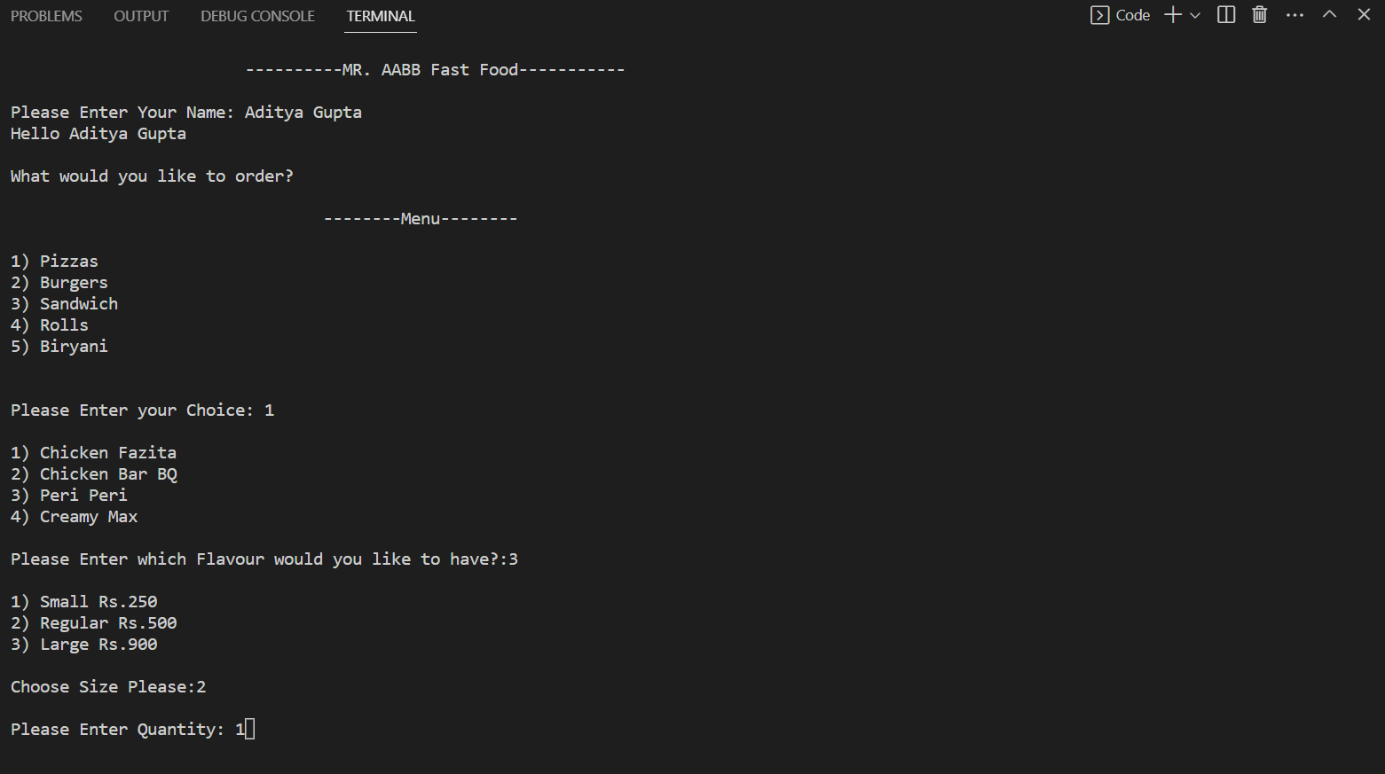

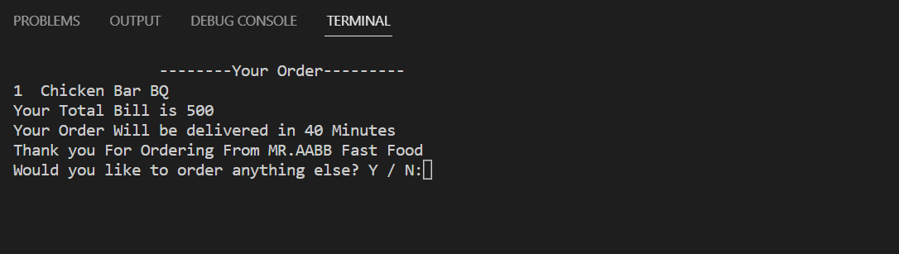

OUTPUT:2

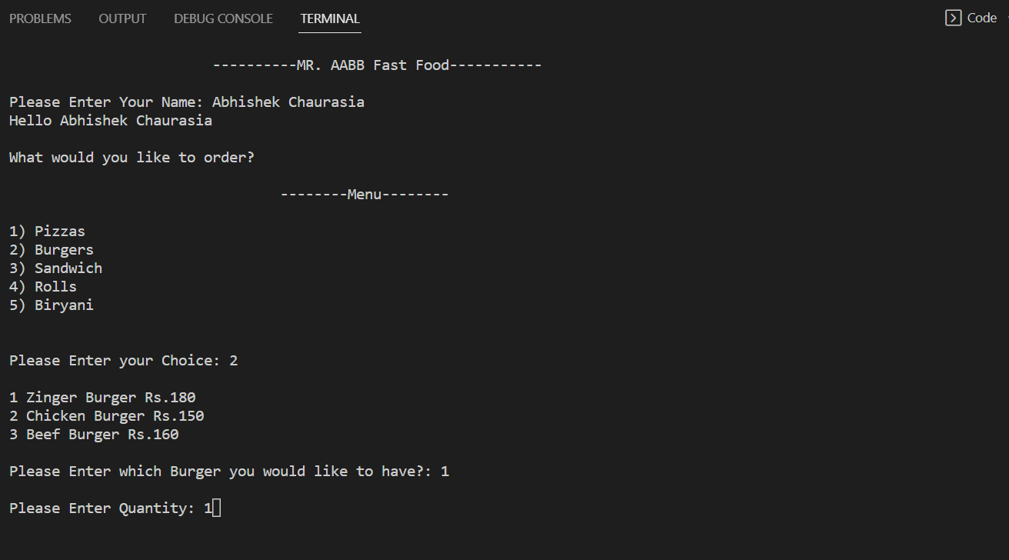

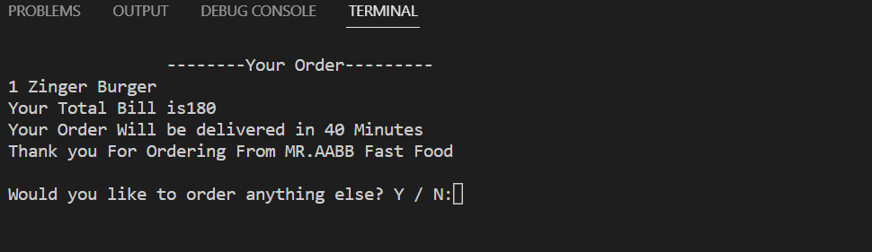

# Conclusion

Hence, Online Ordering management System is web application to restaurant management. This system is to provide service facility to restaurant and also to the customer. The services that are provided is food ordering and table reservation by the customer through the system online, customer information management, menu information management and report. With the system online, ordering and reservation management will become easier and systematic to replace traditional system where papers are still being used.

# References

[Online UML Diagram Tool | SmartDraw](https://www.smartdraw.com/uml-diagram/uml-diagram-tool.htm)

[UML Use Case Diagram Tutorial | Lucidchart](https://www.lucidchart.com/pages/uml-use-case-diagram)

[Unified Modeling Language (UML) | State Diagrams - GeeksforGeeks](https://www.geeksforgeeks.org/unified-modeling-language-uml-state-diagrams/) [What is a Deployment Diagram](https://creately.com/blog/diagrams/deployment-diagram-tutorial/)